Department of Computer Science and Engineering (Data Science)
CSDS-A | Batch A5
JEPA-LLM Tuning Framework for Combating GST and Sales Tax Input Tax Credit Fraud Pattern Detection
METHODOLOGY, NOVELTY AND KEY CONTRIBUTIONS
S.No. | Name of the student | Hall ticket no.
1 | B.ASHRITHA | 23K91A6732
2 | B.DIVYA | 23K91A6739
3 | A.KISHORE | 23K91A6716
4 | A.YAGNESH | 23K91A6711
Project guide: Dr. N. Ch. Ravi, Professor in CSE (Data Science)
TKR College of Engineering and Technology (Autonomous) | A.Y. 2026-27
This document describes how TaxSentinel works end to end, the algorithms used and why they were chosen, what is new against the base paper and the contributions of the project.
Section, table and figure numbers in this document follow the Final Document (17.Final Document.docx) where a section is cited; tables and figures are numbered within this document.

5.2 High-Level Workflow
The workflow in Fig. 1 has eight steps. Data are generated or loaded (1); nineteen features per taxpayer-month are computed in three layers (2); the JEPA encoder scores the deviation of each month (3); the trade graph is analysed for loops and clusters (4); every invoice is scored (5); the four layer scores are combined into a risk (6); evidence and invoice chains are built for the flagged taxpayers (7); and on request a case note is written and checked (8). Evaluation against injected labels and the rule baseline runs on the same scores.
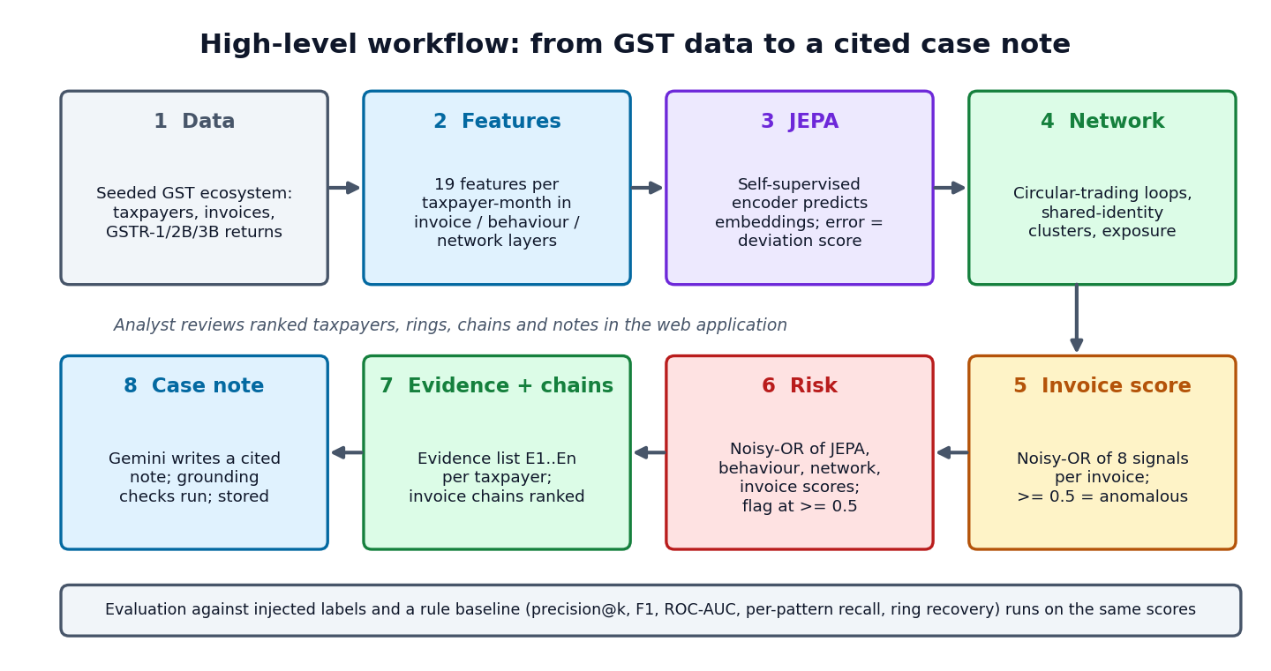
Figure 1: High-level workflow from GST data to a cited case note

6.1 Overall Methodology
The methodology has seven stages that mirror the workflow in Chapter 5. (1) A seeded generator produces a GST ecosystem with injected, labelled fraud and legitimate hard negatives. (2) Three layers of features (invoice, return behaviour and network) are computed for every active taxpayer-month. (3) A JEPA encoder is trained, without labels, to predict the embedding of a month from the embeddings of the previous three months and from the month itself with one feature layer hidden; the prediction error is the deviation score. (4) The trade graph is searched for short recurring cycles and for registrations that share an address or contact number. (5) Every invoice receives a noisy-OR anomaly score from eight weighted signals. (6) The four layer scores are combined into one risk per taxpayer, taxpayers and invoice chains are ranked, and patterns and evidence are derived. (7) Gemini writes a cited case note from the evidence on request, and the result is checked. Evaluation against the injected labels and against a rule baseline is run on the same scores (Fig. 2).
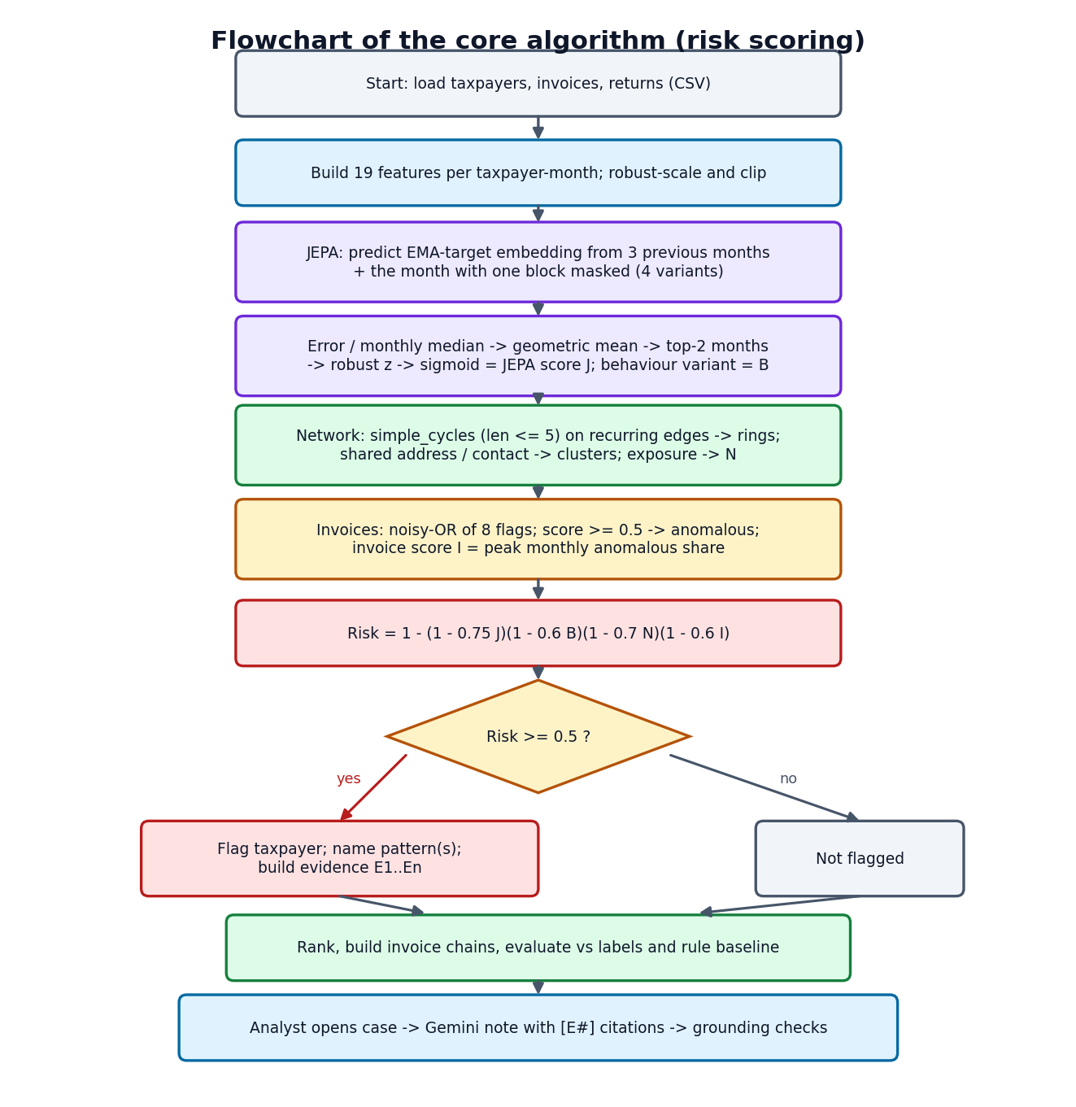
Figure 2: Flowchart of the core algorithm (risk scoring)

6.2 Dataset
Real GST returns are not publicly available, so the project uses a seeded synthetic ecosystem generated by scripts/generate_gst_data.py. The bundled ecosystem (seed 42) covers one financial year, April 2025 to March 2026, and contains 600 taxpayers, 64,474 business-to-business invoices and 6,977 monthly returns. Taxpayers are placed in eight states, five sectors (retailer 178, wholesaler 161, manufacturer 116, services 95, raw material 50) and four constitutions (proprietorship 235, private limited 196, LLP 91, partnership 78). Each has a GSTIN in the official format with a valid check character, a legal name, a registration date, an address and a masked contact. Trade follows a tiered supply network (raw material to manufacturer to wholesaler to retailer, with services supplying every tier). Of the invoices, 39,582 carry an e-way bill and 1,071 were not reported by the seller in GSTR-1.
Each month a taxpayer has a return holding outward taxable supplies, output tax, ITC available in GSTR-2B, ITC claimed in GSTR-3B, tax paid in cash from a credit carry-forward ledger and filing delay. Four fraud patterns are then injected, each with ground-truth labels:
Table 1: Injected fraud in the bundled ecosystem
Pattern | How it is injected | Taxpayers | Other
Shell entities | Young look-alike firms sharing an address or contact number; layered fake invoices; almost no cash tax; they stop filing | 27 (7 clusters of 3-5) | Fake invoices are part of the 530 labelled invoices
Fake-invoice buyers | Established businesses claiming ITC on invoices bought from shell clusters | 19 | No goods moved
Circular trading | Rings of 3-5 firms passing similar values A to B to C to A in the same months | 21 (5 rings of 3-5) | Ring invoices are labelled
ITC spikes | A month's claim far above both history and GSTR-2B | 12 | One-month events

In total 79 taxpayers (13.2 %) and 530 invoices (0.82 %) are labelled fraud. The generator also builds hard negatives on purpose, so that detection is not trivial: festival seasonality, one-off capital purchases, new registrations, group companies sharing an address, late filers, prior-period credit catch-ups, and naturally reciprocal trade between services and manufacturers. The labels live in the CSV files only so that evaluation can run; the model never reads them. The generator is seeded, so the same seed always produces the same ecosystem; the application can generate others (150 to 1,500 taxpayers) from the Overview page. The data is synthetic sample data and is licensed as part of the product.
A second dataset is used only as a transfer check. PaySim [21] is a synthetic mobile-money transaction simulator published on Kaggle under a CC BY-SA 4.0 licence. A 100,000-row seeded random sample (134 fraud rows) is committed under data/sample/; the full 470 MB file is downloaded on demand and ignored by version control.

6.3 Preprocessing and Feature Layers
Every active taxpayer-month (a month in which a return was filed) becomes one vector of 19 features in three layers (Table 2). Counts, turnover and ITC are log-transformed because they are heavy-tailed. Shares are kept in [0, 1]. Ratios are capped (for example ITC to output tax at 5). Features are then robust-scaled: each feature is centred on its median and divided by its robust spread (IQR/1.349, with a floor of half the standard deviation and a small constant), and clipped to [-10, 10]. Months with no return are marked absent; they are not imputed, and the context window handles them with a presence mask.
Table 2: The 19 features in three layers
Layer | Features
Invoice (6) | purchase invoices (log count); sales invoices (log count); share of purchase value not reported by suppliers in GSTR-1; share of goods invoices of Rs 50,000 or more without an e-way bill; share of round-value invoices; share of purchases from suppliers registered less than 6 months before the invoice
Behaviour (7) | outward turnover (log); ITC claimed (log); ITC claimed to output tax; ITC claimed above GSTR-2B (signed log of the relative excess); share of output tax paid in cash; filing delay (months); registration age (log)
Network (6) | number of suppliers (log); number of buyers (log); share of new trading partners; share of sales to parties that also supply the taxpayer (reciprocity); largest buyer's share of sales; value added ((outward - purchases) / (outward + purchases))

6.4 Algorithm Choice and Justification
Why a self-supervised predictive model. The abstract requirement is to learn normal behaviour without labels. The usual options are density or distance methods such as isolation forests [14], reconstruction methods such as autoencoders and predictive methods. JEPA [8], [9] was chosen because it is predictive (it asks whether a month is what the history and the other layers would lead one to expect), because it predicts in an embedding space (so noise in heavy-tailed values is not something it must reproduce) and because its masking gives interpretable variants: hiding a whole month tests predictability from history, hiding a feature layer tests consistency between layers. An exponential-moving-average target encoder [11] and a variance term [12] prevent the representation from collapsing to a constant. The project did not run a head-to-head experiment against an isolation forest or an autoencoder, so the choice is justified by design, not by measured superiority; the ablation in Chapter 8 does show that JEPA on its own is not sufficient.
Why explicit network analysis. Circular trading and shell clusters are properties of groups. A per-taxpayer encoder cannot see a loop, and 27 similar shell firms form their own "normal" in feature space. Bounded-length cycle enumeration [17] on a pruned graph is exact, fast on this data (79 candidate cycles were scanned) and gives an interpretable object, the loop, that can be drawn and cited. Graph neural networks [19] were not used because they would need labels and would remove the explicit loop evidence.
Why noisy-OR. The layers are different kinds of evidence, any of which can be strong enough on its own. A noisy-OR [22] treats each layer as an independent cause with a weight: one strong layer raises the risk, several agreeing layers raise it further, and the result stays in [0, 1]. It has four parameters that an analyst can read, unlike a learned combiner that would need labels.
Why a prompted LLM with grounding checks. Writing a note that an officer can read quickly is a language task. The risk of hallucination [24] is controlled in the way retrieval-augmented generation [23] does it, by supplying the facts, and then checked automatically. Fine-tuning would need a corpus of real investigator notes that does not exist here, so the "tuning" of the LLM in this project is prompt engineering plus verification.

6.5 Mathematical Formulation
Features. Let x(i,t) be the 19-dimensional raw feature vector of taxpayer i in month t, and z(i,t) = clip((x - med) / s, -10, 10) its robust-scaled version, where s = max(IQR/1.349, 0.5 std, 10^-3) per feature.
JEPA. Let f(theta) be the online encoder, f(xi) the target encoder (a copy updated as an exponential moving average, with no gradient) and g(phi) the predictor. For a sample (i,t) and a mask variant v in {0, 1, 2, 3}, let k(v) be a binary keep-vector that hides everything (v = 0) or the invoice, behaviour or network block (v = 1, 2, 3), and let m be the presence indicator of the previous W = 3 months. The prediction and the target are
s_hat = g( [ m1 * f(z(t-1)), m2 * f(z(t-2)), m3 * f(z(t-3)), m, f( k(v) * z(t) ), onehot(v) ] ), s = f_target( z(t) ) (1)
and the training loss is the prediction error in embedding space plus a variance regulariser over the embedding dimensions j of a batch,
L = mean( (s_hat - s)^2 ) + lambda * mean_j ReLU( 1 - std_j( f(z) ) ), lambda = 1 (2)
xi <- 0.99 xi + 0.01 theta (after every optimiser step) (3)
Deviation score. After training, the squared embedding error of each variant is e(i,t,v). It is normalised by the median over taxpayers of the same month and variant, r(i,t,v) = e(i,t,v) / median_i' e(i',t,v), and the four variants are combined by a geometric mean,
d(i,t) = exp( (1/4) * sum_v ln r(i,t,v) ) (4)
The taxpayer's raw deviation is the mean of its two largest monthly d values. It is converted to a score in (0, 1) by a robust z-score against all taxpayers and a logistic squash centred at two robust standard deviations,
J(i) = 1 / (1 + exp( -1.5 * ( u(i) - 2 ) )), u(i) = ( ln raw(i) - median ) / ( 1.4826 * MAD ) (5)
The behaviour score B(i) is obtained in the same way from the largest monthly r value of the behaviour-masked variant alone, which responds to a one-month ITC spike that the averaged score smooths away.
Circular trading. For a directed cycle C in the graph of recurring (at least two months), above-median edges, with edge values v(e), purchases P(w) of node w and common trading months M(C),
score(C) = sqrt( min_e v(e) / max_e v(e) ) * min( 1, |M(C)| / 3 ) * sqrt( min( 1, min_(u,w in C) v(u,w) / P(w) ) ) (6)
The three factors are balance (similar values around the loop), recurrence (the whole loop trades in the same months) and concentration (the loop is a large share of every member's purchases). Cycles scoring at least 0.25 are kept and overlapping cycles are merged into rings.
Shared-identity clusters. Registrations linked by a shared address or contact number form a cluster with score 0.4 * mean J + 0.2 * (share registered within a year) + 0.2 * (intra-cluster share of sales) + 0.2 * (share that stopped filing); a cluster is suspicious at 0.4 or more.
Invoice anomaly. With flags f and weights w(f) (unreported 0.30, no e-way bill 0.30, round value 0.15, young supplier 0.20, supplier in a suspicious cluster 0.35, supplier later stopped filing 0.20, edge of a detected loop 0.45, value more than four times the supplier's median 0.15), the anomaly score of invoice a and the invoice-layer score I(i) of a taxpayer are
A(a) = 1 - prod_f ( 1 - w(f) ), I(i) = min( 1, 1.5 * max_t flagged value share(i,t) ) (7)
An invoice is anomalous when A(a) is at least 0.5. The network score N(i) is the largest of twice the peak share of purchases from suspicious clusters (capped at 1), the score of any ring the taxpayer belongs to, and the cluster score if it is suspicious.
Combined risk. The four layer scores are combined by a weighted noisy-OR and a taxpayer is flagged at 0.5 or more,
R(i) = 1 - ( 1 - 0.75 J ) ( 1 - 0.6 B ) ( 1 - 0.7 N ) ( 1 - 0.6 I ), flag if R(i) >= 0.5 (8)
Evaluation. With y the injected label, P@k is the fraction of fraud among the k highest-risk taxpayers, R@k the fraction of all fraud found among them, F1 = 2PR/(P+R) at the flag threshold, and ROC-AUC the probability that a random fraud taxpayer scores above a random legitimate one.

6.6 Model Architecture and Training
The online encoder is a three-layer perceptron, 19 inputs to 64 (linear, layer normalisation [30], GELU [31]) to 64 (linear, GELU) to a 32-dimensional embedding. The target encoder is a copy of it. The predictor is a perceptron from 3 x (32 + 1) + 32 + 4 = 135 inputs (three context embeddings and their presence flags, the embedding of the masked current month and a one-hot of the mask variant) through two hidden layers of 128 with GELU to a 32-dimensional output. The saved model holds 53,420 values: 7,648 in the online encoder, 7,648 in the EMA target copy, 38,048 in the predictor and a 76-value mask buffer; the trainable part is 45,696.
Table 3: JEPA training configuration (experiments/metrics.json)
Setting | Value
Samples | 6,977 taxpayer-months (all present months; no labels, no train/test split)
Window / mask variants | 3 previous months / 4 (whole month, invoice, behaviour, network)
Optimiser | AdamW [26], learning rate 1e-3, weight decay 1e-4
Batch size / epochs | 256 / 100
EMA momentum / variance weight | 0.99 / 1.0
Seed | 42 (torch and numpy)
Hardware / time | CPU only; 11.7 s for 100 epochs
Final loss | 0.1115 (the loss rises to a peak of 0.261 at epoch 11 as the EMA target moves, then falls and settles)

The loss curve (Fig. 3) is not monotone: it rises over the first ten epochs. This is expected with a moving target, because the online encoder's embeddings first spread out under the variance term and the target follows with a delay. The loss then falls steadily and settles between 0.11 and 0.12 from about epoch 60.
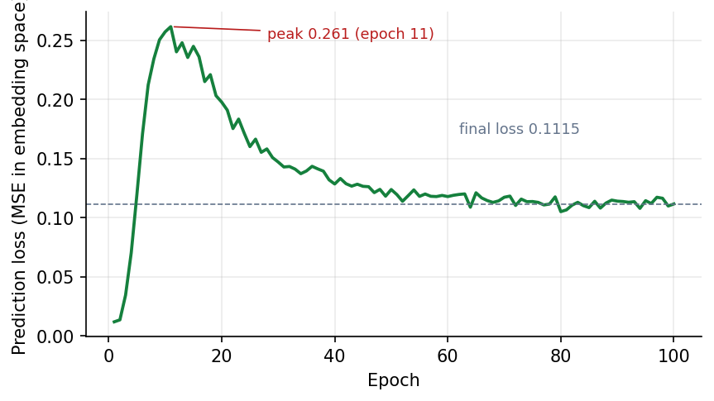
Figure 3: JEPA training loss over 100 epochs (final 0.1115)

6.7 Network, Invoice and Risk Pipeline
ml/pipeline.py strings the stages together. After the JEPA scores, it builds the directed trade graph (edge attributes: total value, tax, count, months and unreported value) and runs the bounded cycle search; on the bundled ecosystem 79 candidate cycles were scanned, which merged into 9 rings, 7 of which contain injected-fraud taxpayers. It then builds identity clusters (12 clusters in total, 7 suspicious), scores each invoice, forms the layer scores, combines them and ranks the taxpayers.
Patterns. A flagged taxpayer is given a named pattern from the evidence: circular trading if it belongs to a ring; shell entity if it is in a suspicious cluster and is young, has stopped filing or pays almost no cash tax; fake invoices if it is not a shell entity but buys from suspicious clusters (10 % of purchases or more in some month) or has at least 15 % of purchase value flagged; ITC spike if a month's claim is at least 2.5 times its median, above Rs 1 lakh and at least 1.5 times the available credit; and unusual behaviour if nothing else applies but the JEPA score is at least 0.5.
Evidence. For every taxpayer, up to eleven kinds of evidence item are produced with a layer, a severity and concrete numbers: JEPA deviation with the three largest feature shifts, months where the GSTR-3B claim exceeds GSTR-2B, ITC spikes, low cash payment against the sector median, suspicious purchase and sales invoices, ring membership with the loop path, the shared-identity cluster, exposure to shell suppliers, stopped filing and high turnover soon after registration. Items are sorted by severity and numbered E1 to En.
Invoice chains. Each detected ring and each suspicious cluster (together with its buyers) becomes a chain with a score built from the ring or cluster score and the risk of its members or the anomalous share of its invoices. On the bundled ecosystem there are 16 chains.

6.8 Evidence and Written Explanation
backend/app/services/explainer.py builds a prompt from the taxpayer's profile, scores, suspected patterns and evidence list and sends it to Gemini under a fixed system prompt. The prompt allows only facts in the evidence list, requires a citation such as [E2] after each claim, forbids legal conclusions, keeps amounts in the evidence's format (rupees with L for lakh and Cr for crore), fixes three sections (Summary, Why it was flagged, Suggested next steps) and limits the note to 320 words. The temperature is 0.2. If the primary model is busy or rate-limited the request is retried once after three seconds and then handed to fallback models.
Every note is then checked automatically against the evidence: the number of citations, the number of invalid citations (citing an ID that does not exist), the share of evidence items cited, the share of high-severity items cited, the share of the numbers in the text that also appear in the evidence, the presence of the three sections and the word count. The note, the evidence that backed it and these checks are stored together, so that a stored note can always be audited. This is how the project turns "tuning" of the language model into something measurable.

Novelty against the Base Paper
The base paper [1] establishes what ITC fraud looks like and why analytics and forensics are needed, but contains no detection model and no evaluation. The novelty of this project is therefore not a competing result on the same task; it is the construction of the model that the base paper calls for. Table below separates what is taken from the base paper from what is new.
Table 4: What is adopted from the base paper and what is new in this project
Aspect | Base paper [1] | This project
Fraud patterns | Describes fake invoicing, circular trading and shell companies | Adopted as the three detection targets, plus ITC spikes; each is injected, detected and measured
Method | Recommends analytics, network analysis and AI-based risk modelling; no model | Implements a self-supervised JEPA behaviour encoder, network detectors, invoice scoring and a combined risk
Evidence | Government statistics and case studies | Per-taxpayer numbered evidence computed from the data
Labels | Not applicable | Learns normal behaviour without labels; labels used only to evaluate
Evaluation | None (qualitative) | Precision@k, recall@k, F1, ROC-AUC, ablations, per-pattern recall, ring recovery, transfer check, cross-seed study
Explanation | Not addressed | Cited, automatically checked case notes
Delivery | Policy recommendations | A secured, working web application

What is new in the technique
- JEPA for tax behaviour. The JEPA recipe, so far applied to images and video, is transferred to monthly tax behaviour vectors, with mask variants that correspond to meaningful hypotheses (history, invoice layer, behaviour layer, network layer).
- Layer-attributed deviation. Because each layer can be hidden in turn, the model can say which layer a deviation lives in, and the behaviour-block variant is used separately to catch one-month ITC spikes.
- Evidence-gated language generation. The LLM may only restate computed evidence and its output is checked for citation validity and numeric grounding; the quality of a note is therefore a measurable number, not an impression.
- A deliberately honest baseline and ablation design. The comparison is against rules that a scrutiny desk actually runs (R1-R5), and the ablation shows that JEPA alone is the weakest component, which is what motivates the multi-layer design.

Key Contributions
- A reproducible synthetic GST ecosystem generator with four labelled fraud patterns and seven kinds of legitimate hard negative (64,474 invoices and 79 fraud taxpayers in the bundled ecosystem).
- A 19-feature, three-layer representation of taxpayer-months (invoice, behaviour and network).
- A 53,420-parameter JEPA behaviour encoder with four mask variants, trained without labels in 11.7 s on a CPU.
- A scored circular-trading detector (balance, recurrence, concentration) that recovered 5 of 5 injected rings, and a shared-identity shell-cluster detector.
- A noisy-OR multi-layer risk model that reaches precision@79 of 0.949, F1 0.955 and ROC-AUC 0.997 on the bundled ecosystem against 0.620, 0.432 and 0.876 for the rule baseline, with ablations showing every layer's role.
- An invoice-level anomaly score with F1 0.924 against 0.160 for the standard GSTR-1 mismatch check.
- Cited, automatically checked LLM case notes (0 invalid citations over 6 evaluated notes).
- A cross-seed study and a threshold sweep that quantify how far the headline figures generalise and how sensitive they are to the flag threshold (Chapter 8).
- A secured, tested full-stack application (FastAPI and React) with ranking, profile, graph, chain, case-note, performance and history screens.

